双中实验校教育集团2020届七下半期考试
英语试题
考试时间120分钟，满分150分

第一部分 听力测试（共30分）
一、听句子，根据所听到的内容选择正确的答语。每题读两遍。（共5小题，每小题1分，共5分）
1. A. Yes, I do. B. Yes, I can. C. Yes, I am.
2. A. The music club. B. I’m in the music club. C. I want to swim.
3. A. It’s ten minutes. B. By subway. C. It’s five kilometers.
4. A. At half past six. B. For half an hour. C. On Monday.
5. A. Thank you. B. Sorry, Ms Brown. C. Yes, you are right.
二、听句子，选择与你听到的句子意思相符合的图片，并将代表图片的字母填在相应的位置。每小题读两遍。（共5小题，每小题1分；计5分）
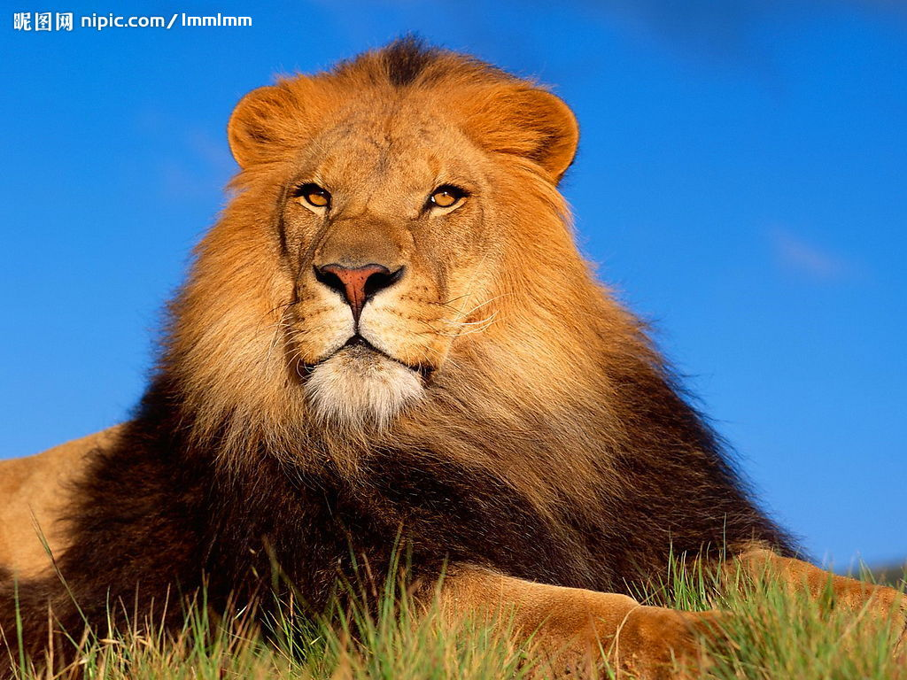
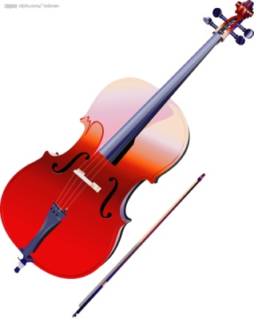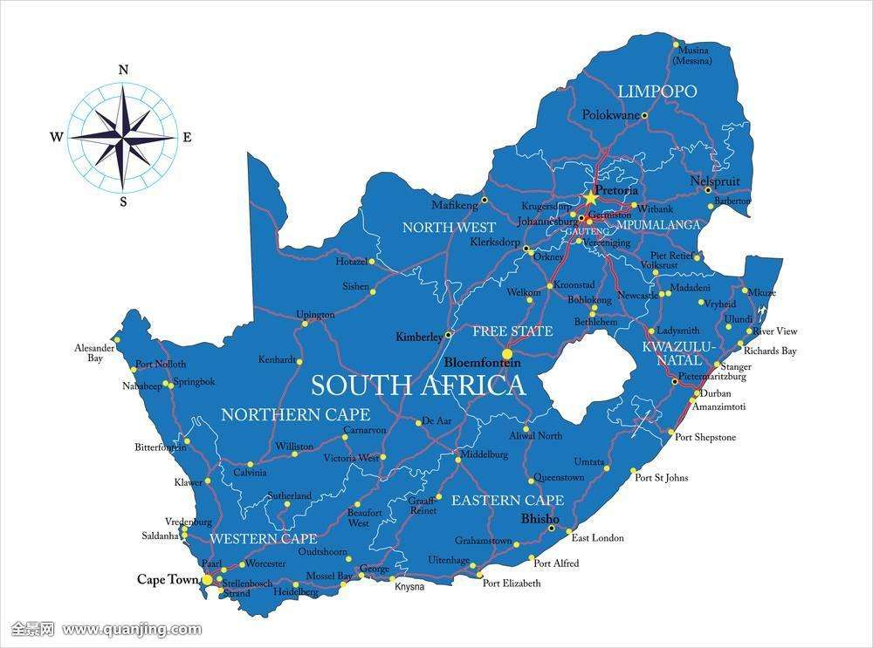
A B C D E
6. _____________ 7.__________ 8.__________ 9.__________ 10.__________
三、听对话，根据内容及问题选择正确答案。每段对话读两遍。（共10小题，每题1分；计10分）
( )11. A. Play basketball. B. Do his homework. C. Clean his room.
( )12. A. Reading a newspaper. B. Washing clothes. C. Reading a book.
( )13. A. Tigers are big cats. B. Tigers are cool. C. He is afraid of tigers.
( )14. A. A basketball club. B. A soccer club. C. A music club.
( )15. A. At seven. B. At half past seven. C. At twenty to eight.
( )16. A. A hamburger and an egg. B. A hamburger and milk. C. An egg and milk.
( )17.A. Don’t eat in the classroom. B. Don’t be late for class.
C. Don’t run in the hallway.
( )18. A. His cousin. B. His parents. C. His sister.
( )19. A. Have a trip. B. Cut down trees. C. Join a club.
( )20. A. 55. B. 48. C. 30.
四、听短文，根据短文内容选择正确答案。短文读两遍。（共5小题，每小题1分；计5分）
( )21. What does the writer think of Jack?
A. He is friendly. B. He works hard. C. He is lazy.
( )22. Where does Jack’s mother work?
A. In a police office(办公室) . B. At a school. C. In a hospital.
( )23. What does Jack want to be after he finishes school?
A. A teacher. B. A cleaner. C. A doctor(医生) .
( )24. How many days does Jack think cleaners work in a week?
A. One day. B. Three days. C. Five days.
( )25. What’s right?
A. Jack isn’t good at math. B. Maybe Jack’s father wants Jack to be a doctor.
C. The men only work on Tuesday.
- 听短文，根据短文内容完成表格中所缺信息。短文读三遍。（每题1分，共5分）
_____26______
If you read here | ※ You can be here for ____27_____ on school days.  ※Don’t bring other books or ____28______ to the library.  ※You can take two books from the shelf at a time(一次).  ※Don’t be ____29____.  ※Don’t eat here. It may make the library dirty.
If you borrow(借) books | ※Use your card.  ※You can borrow three books at a time.  ※Give back(归还) the books ____30______.  ※Don’t lose the books.

第二部分 基础知识运用(共70分)
六．单项选择。（20分）
A、从A、B、C三个选项中选择能填入空白处的正确答案。（每题1分，共10分）
( ) 31. My cousin Lily can play____ chess, but she can’t play _____ piano.
A. the, / B. /, / C. /, the
( ) 32. Liangliang is a _______ boy. He crosses the river every school day. But he is not afraid.
A. seven years old B. seven-year-old C. seven-years-old
( ) 33. We can see the sign “_________” in a reading room or a library.
A. NO SWIMMING B. NO DANCING C. NO TALKING
( ) 34. My mother often takes a walk after dinner ________ an hour every day.
A. at B. on C. for
( ) 35. ---What time is it now?
---Let me see.
A. It’s thirty-five to six. B. It’s half to six C. It’s six fifty.
( ) 36. There are many animals in the zoo. Some are cute and smart, but some are ______.
A. beautiful and friendly B. scary and unfriendly C. scary and interesting
( ) 37. — Where is your brother, Lisa?
— Oh, he ______ a newspaper in his room.
A. reads B. is riding C. is reading
( ) 38. — Can we eat food in the classroom, Ms Smith?
— No, you ______. And you ______ eat food in the dining hall.
A. can’t; can’t B. don’t; can C. can’t; have to
( ) 39. Steve is like a big brother to the students in the village, he is good _______ them.
A. at B. for C. with
( ) 40. — Have a good day!
— _________________.
A. It’s OK. B. Thanks. You, too. C. Good.
B、根据对话内容，从下边方框中选择恰当的选项补全对话，并将选项的编号依次填入题前括号内。（每题2分，共10分）
A: Hello? This is Dale speaking.
B: Hi, Dale. It’s Dave. What are you doing now?
A: 41
A. How long do you need to finish your homework?
B. Let’s meet at 4:15 at your home.
C. It’s one of my family rules.
D. You can do your homework this evening.
E. I’m doing my homework.
B: Let’s go swimming. 42
A: Sorry, I have to do my homework first.
43
B: I see. 44
A: About an hour.
B: It’s 3 o’clock now. 45
A: OK. See you then.
B: See you.
41. （ ） 42.（ ）43. （ ）44. （ ） 45. （ ）
七、完形填空。（共15题，计20分。 A篇每题2分，计10分； B篇每题1分，计10分）
A
My name is Jeffery. I’m from America. My favorite animals are koalas, because they’re very cute. Do you 46 about koalas? Let me tell you something about them.
Koalas live in Australia. They have small black eyes and big ears. 47 hair is usually gray and brown. They are about 70-80 cm long. 48 do they like to eat? Eucalyptus leaves (桉树叶). They don’t usually drink, because they can get much ____49____ from the eucalyptus leaves. They 50 in the trees in the day, but at night they get up and have food. They often sleep for 16-18 hours a day.
Koalas are in danger now. Today there are about 43,000 koalas (100,000 before). People cut down trees and kill koalas. We must do something to save them.
( ) 46. | A. think | B. know | C. listen
( ) 47. | A. His | B. Our | C. Their
( ) 48. | A. What | B. Why | C. When
( ) 49. | A. water | B. food | C. exercise
( ) 50. | A. walk | B. sleep | C. run

B
Robbie is an eleven-year-old boy, he 51 in a middle school. He likes P.E. and his favorite sport is soccer. But he 52 plays soccer with his classmates. Why? Because he doesn’t have feet.
One day, I see a 53 of Beckham(贝克汉姆) on his desk and ask, “ Is this 54 ?”
He says, “ Yes. I take this photo of him 55 March. I want to be a soccer player, But …”
“ I see, Robbie. Today, I want to 56 you a story. A boy is locked (被锁住) in a room. He thinks he can’t 57 . Actually（事实上） there is a door all the time 58 the boy can’t see it. It is the door of hope(希望).”
Robbie 59 very happy. Then he asks, “ Can I play soccer like 60 students?”
Now Robbie is in the school soccer club. He is very happy every day.
( ) 51. A. works B. studies C. teaches
( ) 52. A. never B. usually C. always
( ) 53. A. picture B. uniform C. movie
( ) 54. A. mine B. yours C. hers
( ) 55. A. on B. at C. in
( ) 56. A. tell B. keep C. wish
( ) 57. A. get up B. go out C. eat out
( ) 58. A. or B. and C. but
( ) 59. A. tastes B. looks C. sounds
( ) 60. A. every B. much C. other
八、 阅读理解。
根据短文内容判断句子的正误。正确的写A，错误的写B。（共5小题，每题2分,共10分）
Sunny School is a great school for children of 6-15. A cook, a library assistant, a P.E. teacher and a French teacher are wanted.
Job | Age | Language | Abilities | Others
A cook | 25-40 | Chinese | Cooking Chinese food and other kinds of food well | Healthy
A library assistant | 20-35 | Chinese;  English | Knowing a lot about all subjects | Healthy;  Harding-working
A P.E teacher | 20-40 | Chinese;  English | Being good at playing basketball | Healthy;  Strict
A French teacher | 20-35 | French | Teaching French well | Healthy;  Friendly
( ) 61. Sunny School needs a French teacher at the age of 20 to 40.
( ) 62. The P.E. teacher needs to be good at playing soccer.
( ) 63. If Mrs. Wang is 40 but isn’t healthy, she can’t work as a cook in Sunny School.
( ) 64. The library assistant needs to know about all the places of Sunny School.
( ) 65. The French teacher must be healthy and friendly to the students.

九、根据短文内容选择正确的答案。（共10小题，每小题2分，计20分）
A
Dear Nancy,
How’s it going with you? It's Sunday today. I'm writing to you. I'm going to tell you about something in Shuangliu.
Shuangliu is different(不同) from New York. In Shuangliu, many people go to work by bus or by car. The rush hours(高峰时间) are from seven to nine in the morning and from five to seven in the afternoon. People in China often work about nine hours a day, five days a week, and they rest on Saturday and Sunday.
I have Chinese classes every morning from Monday to Friday. The students in our class are from many countries. We're all working hard and friendly. The Chinese students are helpful. They often help us with our Chinese. We also help them a lot with their English. We're getting along very well.
That's all for today. Please write to me soon.
Cindy
( ) 66. Maybe Cindy is from__________.
A. China B. America C. South Africa
( ) 67. The rush hours a day in Shuangliu usually last(持续)________.
A. about four hours B. three hours C. over five hours
( ) 68. What does “ rest ” mean(意思) in the letter?
A. work B. learn C. relax
( ) 69. In Cindy's class, students are not_________.
A. lazy B. friendly C. helpful
( ) 70. Which of the following is TRUE?
A. Chinese people often work seven hours every day.
B. All the students in Cindy’s class are Chinese.
C. Cindy is learning Chinese in Shuangliu now.
B
My family go to Sydney, Australia this summer. We get there by plane on Friday evening and we walk to our hotel. When we get to the hotel, we are very sleepy, so we don’t go out.
On Saturday morning, we go around the city. It is very beautiful. We take a hot balloon (气球) to see the city. Then we go to a zoo. We see lions, monkeys and koalas there.
In the afternoon, we take a bus to a park. In the park, the guide(导游) shows nice birds and trees to us. They are different from Chinese birds and trees. We also go to the sea and swim in the water. We take a lot of photos there.
The next day, we do some shopping and buy a lot of presents for our friends. We have a very good time there. I hope I can go there next summer holiday.
( ) 71. How do they go to the hotel after they get to Australia?
A. By plane. B. On foot. C. In a hot balloon.
( ) 72. They don’t see ____ in the zoo.
A. koalas B. monkeys C. tigers
( ) 73. What do they do first on Saturday afternoon? _____
A. They take a bus to a park.
B. They take photos there.
C. They go to the sea there.
( ) 74. When do they do some shopping?
A. On Friday. B. On Saturday. C. On Sunday
( ) 75. What’s the best title (标题) for the passage?
A. A Nice Day. B. A Great Place for Shopping. C. A Great Trip to Australia

B卷 （共50分）
一、英语语音及朗读素养测试。（共10个测试点，每个测试点0.5分，计5分）
1. 重音: 在单词重音位置标出重读符号“ ＇”。
giraffe symbol remember scary
2. 连读：在句子中能连读的位置标出连读符号“ ︶”
1） I usually take a shower at six forty.
2) He often writes to his children and his wife.
3. 语调： 在句子括号处用升调“ ↗”或降调“ ↘ ”符号标出语调。
1） Do you want to go to the ( ) movies or play ( )soccer?
2) May I speak to ( ) David?
二、根据句意及所给首字母提示，完成单词。(每题1分，共5小题，共5分)
1. Be q______! It’s 7:50 now. We must run to school. We can’t be late .
2. My sister’s dream is to be a m__________. She loves playing the piano and violin.
3. He lives far from school so he has to l___________ home early every morning for school.
4. Look! Tony is playing with a snake(蛇). He isn’t a______. But I think snakes are too scary.
5. The mother is in the k________ now. She is making some food for her children.
三、完成对话。在对话的空格上填上恰当的单词，使对话完整正确。一空一词，含缩写词。(每题1分，共10小题，共10分)
A: Hey, Jack! It’s your first day at school. 1 do you think of your new school?
B: It’s a great school. But teachers are very 2 with us students. Teachers always tell
us “ 3 do this!” or “ You can’t do that!” .
A: Really? Like what?
B: Don’t wear a hat in class. We must wear the school 4 on school days. All the
students look the same.
A: Can you bring your phone to class?
B: No, I can’t. I must 5 it at home. The teachers thinks it’s good for my study.
A: Do you have to clean your classroom every day?
B: Um, yeah, we must 6 the classroom clean all day and clean our classroom after school.
A: Don’t only 7 about the things you must do. Are there any things you like to do?
B: YES! There are some interesting lessons at school. I am 8 at drawing. So art lesson is my favorite.
A: Sounds great! Is the art room far from your classroom?
B: Yes, it’s kind of far. I need fifteen minutes to 9 there. We can’t ride at school.
A: It’s good 10 . I hope you’ll enjoy your school life.
B: I hope so.
1._________ 2.________ 3._________ 4._________ 5.__________
6._________ 7.________ 8._________ 9._________ 10._________
四．短文填空。从方框中选择恰当的单词并用其正确形式填入短文空格内，使短文意思正确、通顺，每词限用一次。（每小题1分，共10小题，共10分）
dangerous, noise, be, look, when, symbol, keep, cool, scary, have, over, with

Hello, boys and girls! Welcome to the New York Zoo today. Do you like tigers or lions? Some children think they are too 1 ! But they are not dangerous here in the zoo because we 2 them in the cage (笼子). You can see giraffes 3 long legs from South Africa. There are some pandas from China and koalas from Australia. They are all really cute and friendly. The elephant 4 funny, I’m sure you must be interested in its show. We have 5 100 kinds of birds in the trees here in the zoo but they are really shy, so please don’t be 6 when you walk around the zoo. Those big blue flags over there are the zoo’s 7 for water animals. You can see beautiful fish 8 you see those blue flags. OK, now please don’t forget my name. I’m Somchai, and I come from Thailand. When we walk around the zoo today, please remember 9 friendly to all the animals. They are our friends. Some of them are in great 10 , and we must do something to save them.
1._________ 2.________ 3._________ 4._________ 5.__________
6._________ 7.________ 8._________ 9._________ 10._________
五．阅读表达。
A、阅读下面的短文，根据短文内容，从短文后的选项中选出恰当的选项补全短文（有一多余选项），并将选项的编号依次填入答题卡相应位置。（注：本题请用2B铅笔涂在机读卡上第76到80小题处）。(共5小题，每小题1分，共5分)
I study in No.1 Middle School. We have four classes in the morning. There is a thirty minutes break between the second and the third class. 1 .Look! Some students are on the playground.They are playing basketball. Oh! A boy is running with the ball. 2 .They look so cool. And there are some girls watching the game. Some students are in the classroom. They are quiet. 3 .Look! A girl is looking at the birds in the tree outside. 4 .What are the teachers doing? 5 . And some are talking with students. We all like our school and we all enjoy our school life.
- They are doing some cleaning.
B. She must be thinking of something interesting because she is smiling.
C. Some of them are working in the office（办公室）.
D. And another one is trying to stop him.
E. Some of them are reading and some are doing their homework.
F. Most of us are playing during the break time!

1._________ 2.________ 3._________ 4._________ 5.__________
B、阅读下面短文，根据短文内容，补全表格中所缺的信息，并将答案按编号顺序依次填入答题卡相应的位置。(共5小题，每小题1分，共5分)
Students from different places live different life and have different dreams.
Xiao Yu is a middle school student from a small village in Guangyuan, Sichuan. His school is far from his home, so he has to get up early and walk to school. He’s never late. After school, he helps his grandparents with housework first. His parents are not at home because they work in Dongguan, Guangdong. They only go home one or two times a year. Sometimes, it’s really difficult to get a train ticket(票). So Xiao Yu can’t see his parents all year. He hopes to see his parents very often.
Doudou is a little girl from Dalian. It’s a beautiful city. She lives kind of far from her school, so she goes to school by bike every morning. After school, she likes reading books about animals. She really wants to have a pet dog. She likes dogs best of all the animals. But her parents don’t let him have one at home. They think a dog will make the room dirty.
John is a young father from Seattle. It’s a big and modern city in USA. It’s very easy for him to take the subway to get to work. It takes him only 5 minutes to walk to the subway station from his home. His son is only 4 years old. He wants to take him to places with lots of trees on weekends. So his dream is to buy a car this year. He hopes his son will be happy every day. So, he’s working really hard.

Name | How to get to school or work | their 1 | Reasons(理由)
Xiao Yu | He goes to school early  2 . | To see his parents very often. | Parents can’t come back home very often.
Doudou | She rides her bikes to school every morning | 3 | 4 are dogs.
John | First, he 5  Then, he goes to work by subway. | To buy a car | He wants to take his son to  places with lots of trees.

1._________ 2.________ 3._________ 4._________ 5.__________

六．书面表达。（10分）
假如刘亮是你的朋友，请根据以下表格信息提示，完成一篇70词左右的文章介绍刘亮的生活学习情况。
注意：文章条理要清晰，完整流畅，可以适当发挥。
起床时间 | 7：20
上学距离 | 20千米
上学方式及所花时间 | 坐地铁、15分钟
校规 | 2条校规
俱乐部活动 | 讲故事
家庭的宠物 | 自由谈论
周末家庭活动 | 谈论一项活动

____________________________________________________________________________________________________________________________________________________________________________________________________________________________________________________________________________________________________________
______________________________________________________________________________________________________________________________________________________
___________________________________________________________________________
______________________________________________________________________________________________________________________________________________________
___________________________________________________________________________

