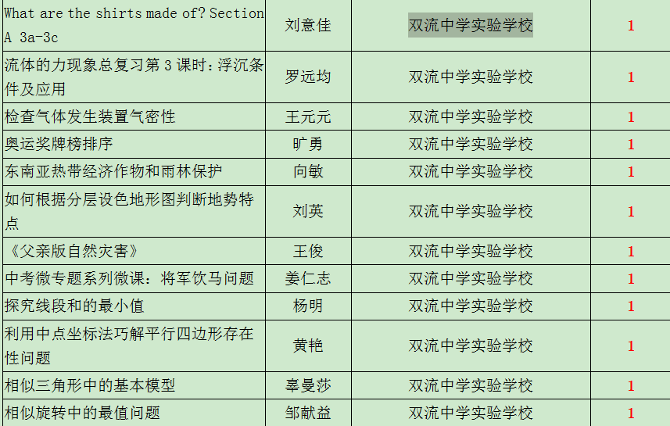

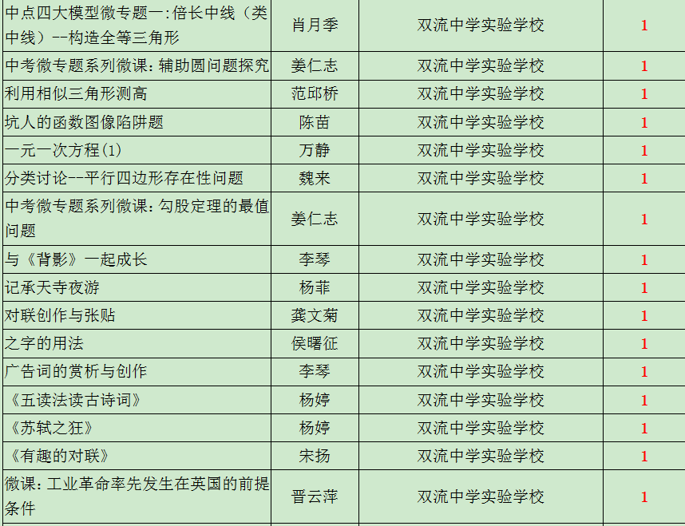

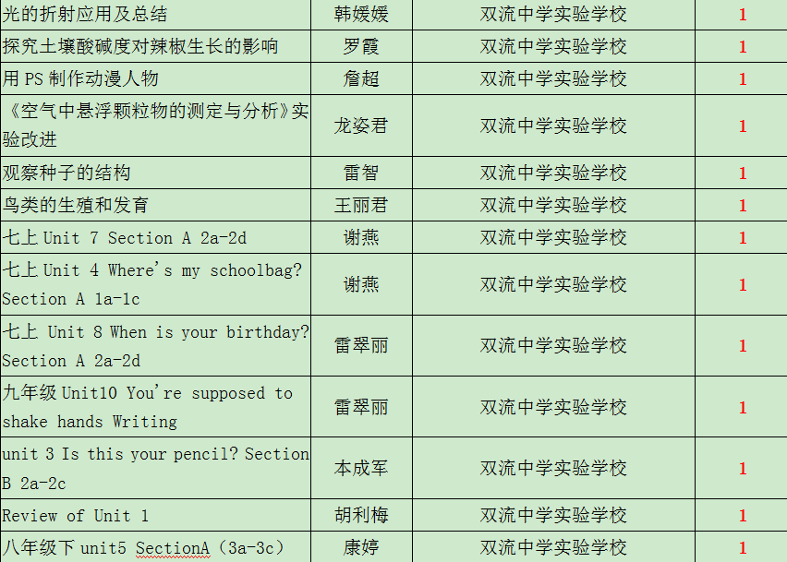

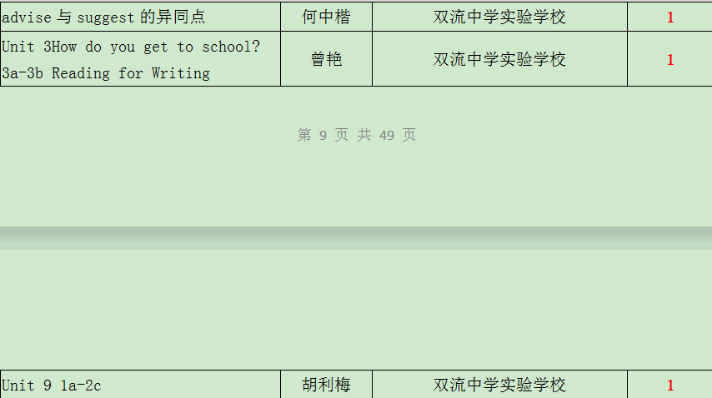

C:\Users\Administrator\Documents\Tencent Files\505035014\Image\C2C\W48HD_W{GR(@K[V%$H~1$64.png

C:\Users\Administrator\Documents\Tencent Files\505035014\Image\C2C\]GQU[(V1[(JD){NTNO8VZ8V.png